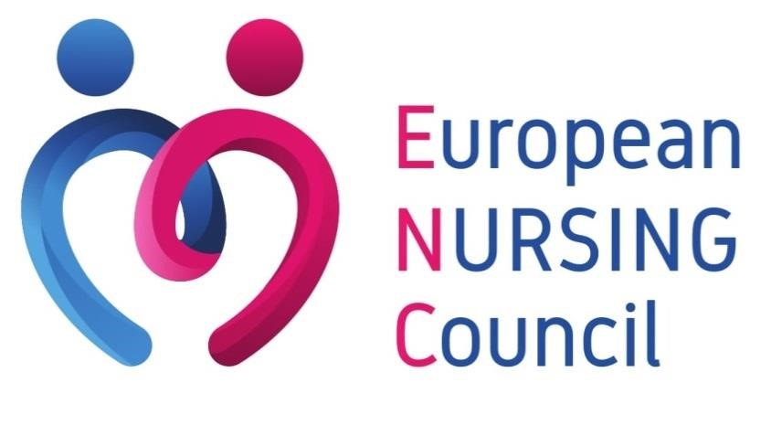

News from Brussels

Year 2023 – Issue n°7
#7

- European Commission offers €100 million for innovative solutions to health threats

- European Parliament adopts a roadmap to better prepare for future health crisis

- European Commission wants to prevent shortages of antibiotics for next winter

- United Kingdom: Half of nurses report seeing patients with money-related health issues

European Commission offers €100 million for innovative solutions to health threats

The 12th of July, the European Commission and the European Investment Bank, has announced the creation of HERA Invest, a €100 million top-up to the InvestEU programme, to support research and development (R&D) in the most pressing cross-border health threats. HERA Invest is going to be financed by the EU4Health programme. This investment shall help innovation, in order to respond to priority health threats such as pathogens with high pandemic potential or resistance to antibiotics.

HERA Invest, an initiative of the European Health Emergency Preparedness and Response Authority, will focus on health emergency prevention and preparedness, helping address these challenges by:

- promoting R&D in Europe to strengthen strategic autonomy;
- reducing market failures, where financial resources do not cover the financing needs;
- leveraging public funding to incentivise private investment;
- creating new medical countermeasures to protect against health threats.

The HERA Invest funding instrument is geared towards small and mid-sized companies (SMEs) that develop medical countermeasures addressing one of the following health threats:

- pathogens with pandemic or epidemic potential;
- chemical, biological, radiological and nuclear threats originating from accidental or deliberate release;
- antimicrobial resistance.

Under HERA Invest, the European Investment Bank (EIB) will provide venture loans, covering a maximum of 50% of total project costs. There is a rolling application process. The EIB assesses whether an operation is eligible based on defined criteria and the project's commercial and scientific viability.

Interested companies can find more information here.

You may find more information about this initiative here.

European Parliament adopts a roadmap to better prepare for future health crisis

The 12th of July, the European Parliament has adopted the report of the Special Committee on the COVID-19 pandemic (COVI) with 385 votes in favour, 193 against and 63 abstentions. Over the past year, COVI has indeed analysed the impact of the crisis, evaluated the effectiveness of EU and national measures, and made specific recommendations to address gaps and weaknesses in their actions.
MEPs have outlined a clear roadmap for future action in four main areas: health, democracy and fundamental rights, social and economic aspects, and global response to the pandemic.

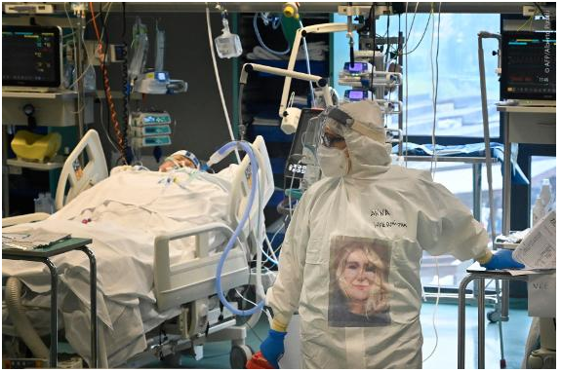
The main proposals include enhancing the EU’s strategic autonomy for medicines, transparency for joint procurement activities, and stronger parliamentary oversight at both EU and national levels for emergency legislation. MEPs also demand the EU to maximise the use of recovery funding to strengthen the Single Market, and plead for an improved global coordination with the upcoming International Pandemic Treaty.

COVI Chair Kathleen Van Brempt, MEP (S&D, BE) stated: “Our Committee has undertaken a thorough assessment of the course of the pandemic and its impact on the EU. It became clear that Europe not only needs the tools to develop long-term policies, with clear goals and roadmaps. It must also be ready to act quickly, efficiently and in the interests of every European. The EU must also thoroughly evaluate its role in the global response to the pandemic and commit more than ever to international cooperation and solidarity, especially with partners in the Global South. It is now up to the European Commission to take our recommendations and table proposals to shape a more crisis-resilient and future-proof EU.”

You may find more information here

European Commission wants to prevent shortages of antibiotics for next Winter

The 17th of July, The European Commission, the Heads of Medicines Agencies (HMA) and the European Medicines Agency (EMA), have issued recommendations for actions to avoid shortages of key antibiotics used to treat respiratory infections for European patients in the next Winter season. These recommendations, which were developed through the Executive Steering Group on Shortages and Safety of Medicinal Products (MSSG), complement the process to develop an EU list of critical medicines. In close cooperation with the EU Member States, the Commission will take operational follow-up actions, including, if necessary, possible joint procurements.
The data collected suggest that supply to the EU of oral formulations of key first and second-line antibiotics for respiratory infections will match demand in the coming Winter season. EMA and the European Health Emergency Preparedness and Response Authority (HERA) will continue to work with marketing authorisation holders to strengthen measures to increase the supply of some intravenous antibiotics.
To be better prepared for the Winter season, the EMA's Executive Steering Group on Shortages and Safety of Medicinal Products (MSSG) agreed on the following recommendations for pro-active actions:
- Increase the production of key antibiotics: To avoid shortages in the upcoming Autumn and Winter season, EMA and HERA are recommending to continue to engage with marketing authorisation holders to step up measures to increase production. Early action ahead of the Autumn and Winter season should give manufacturers enough time to ensure they have sufficient manufacturing capacity to meet the demands.
- Monitoring of supply and demand: EMA and the Commission, together with Member States will continue to monitor the demand and supplies in cooperation with companies. Given that the measures taken are designed to ensure sufficient supply, all stakeholders are reminded to order medicines as normal, with no need to stockpile medicines. Stockpiling medicines can put further strain on supplies and cause or worsen shortages.
- Public awareness and prudent use: Antibiotics should be used prudently to maintain their efficacy and avoid antimicrobial resistance. healthcare professionals have a key role to play, and antibiotics should only be prescribed to treat bacterial infections. They are not suitable for treating viral infections such as cold and flu, where they are not effective. Citizen awareness raising initiatives are also advised.

Commissioner for Health and Food Safety, Stella Kyriakides, stated: “The availability of medicines is a crucial component of a strong European Health Union. It is essential that we take action now to prepare ahead of next winter and ensure that potential shortages of antibiotic medicines are avoided. Today we are taking an important step on measures to address our immediate needs for key antibiotics, complementing the on-going process to develop an EU list of critical medicines. Operational follow-up by HERA and EMA will now follow as a matter of priority.”
You may find more information here.

United Kingdom: Half of nurses report seeing patients with money-related health issues

The 31st of July, the nursingnotes, a well-known British website, has shared the conclusion of a research conducted by the Personal Care Institute (PCI) and the Money and Pensions Service (MaPS). The latter stated that 57% of nurses believe money problems are causing or worsening some patients’ health issues. The current situation is quite alarming as they further noted that things have worsened in the past six months.

The vast majority of nurses (89%) said they felt ill-equipped to speak with patients about their finances, “feeling it’s not their place” or being worried they might not have the answers. The rising cost of living, rent increases, prescription charges, poor diet, and debt are just some of the things contributing towards the UK’s deteriorating health.

Dr Emma Hyde, Clinical Director for the Personalised Care Institute, has warned: “Nurses and other health and care professionals are seeing first-hand how financial wellbeing impacts on health and yet the vast majority, understandably, lack confidence in having these types of conversations with their patients because they are worried about inadvertently making things worse.”

The PCI is actively encouraging nursing staff to have those difficult conversations with patients. In this context, and in collaboration with MaPS, they have developed a toolkit aiming at facilitating the discussion between nurses and patients regarding their financial difficulties (available here).

Associate Chief Nursing Officer and PCI ambassador Rachael Hebbert explained: “As a nurse, it’s vitally important that I care for my patients holistically using a personalised care approach. “I often felt uncomfortable when talking about money matters as I’m certainly no expert, but this simple toolkit, comprising free courses and resources, is really helpful in enabling me to have personalised care conversations with patients regarding their money worries and point them in the right direction for help and advice.”

You may find more information here.

