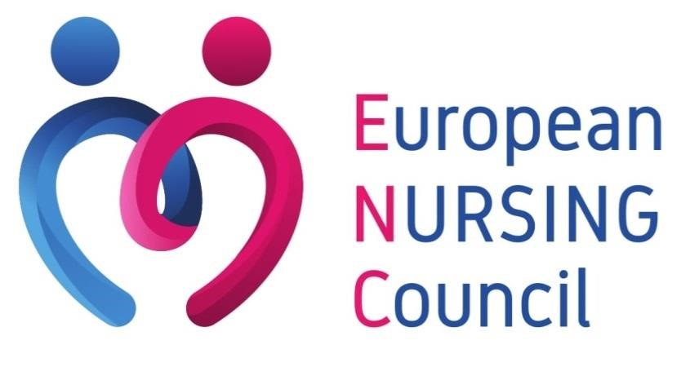

News from Brussels

Year 2023 – Issue n°8
#8

- Keynote Speech by Commissioner Stella Kyriakides at the European Parliament Policy Dialogue: "How Can the EU Pharmaceutical Legislation be a Success for Children and Adolescents with Cancer?"

- The Nurse Conundrum — Why showing kindness to patients does not always go together with showing kindness to colleagues

- WHO Europe Calls for Urgent Investment in Digital Health Literacy

Determinants of the onset and prognosis of the post-COVID-19 condition: a 2-year prospective observational cohort study

Keynote Speech by Commissioner Stella Kyriakides at the European Parliament Policy Dialogue: "How Can the EU Pharmaceutical Legislation be a Success for Children and Adolescents with Cancer?"

On September the 7th, 2023, Commissioner Stella Kyriakides addressed the European Parliament in a keynote speech during Childhood Cancer Awareness Month. She discussed the EU's pharmaceutical legislation and its potential to improve the lives of children and adolescents battling cancer.

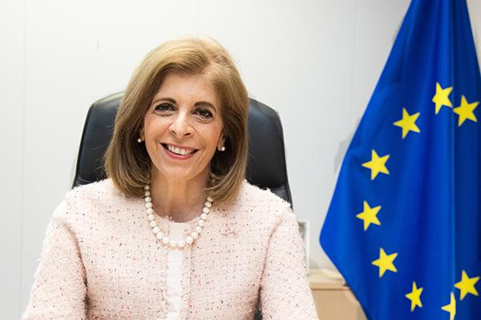
Commissioner Kyriakides began by acknowledging the significant efforts of organizations like the MEPs Against Cancer Interest Group, the European Society for Paediatric Oncology, Childhood Cancer International – Europe, and the European Association of Cancer Leagues. She also expressed gratitude to MEP Loukas Fourlas for hosting the event, recognizing his personal dedication to the cause. The Commissioner paid a heartfelt tribute to MEP Veronique Trillet Lenoir, a passionate advocate for Europe's Beating Cancer Plan and childhood cancer, who was absent but remembered fondly.

The primary focus of Commissioner Kyriakides' speech was on cancer prevention, treatment, care, and timely access to innovative medicines for young patients. She emphasized the importance of collaboration between policymakers, healthcare professionals, researchers, and, most importantly, patients and their families.

While acknowledging the success of existing legislation, the Commissioner noted that more needed to be done to address childhood cancer, which remains the leading cause of death for children in Europe. She highlighted the need to study certain adult cancer medicines for their potential effectiveness in treating children, a proposal included in the reform.

Access to medicines was another critical aspect. The reform aims to address inequalities in access to medicines, ensure faster availability of affordable generics and biosimilars, reduce shortages, and simplify authorization procedures. Commissioner Kyriakides drew attention to the EU's ability to ensure equitable access to COVID vaccines during the pandemic and called for a similar approach to medicines.

Commissioner Kyriakides called for continued support during interinstitutional negotiations on pharmaceuticals, underlining the importance of working together to benefit patients, especially children and adolescents, across Europe. Her deep commitment to improving the lives of young cancer patients and their families was evident throughout her speech, as she reminded the audience of the importance of keeping these young stars shining bright in the sky of the future.

You may find more information about this article, or read the full speech here.

The Nurse Conundrum — Why showing kindness to patients does not always go together with showing kindness to colleagues

We felt that it is interesting to share with you an article published the 14th of September, on the DailyNurse. The subject is the so-called Nurse Conundrum: while nurses are often known for their kindness, care, and compassion towards patients, they can sometimes display unkindness and incivility towards their fellow nurses. This paradox raises questions about why a profession dedicated to healing can sometimes be marred by internal conflict and mistreatment.

“The Ethos of Kindness and Compassion in Nursing

Nursing is synonymous with healing and empathy. Nurses are consistently ranked as trustworthy and honest in Gallup polls, and their choice of profession is lauded by many, including strangers. Patients often have heartwarming stories of nurses going above and beyond in their care. However, there exists a stark contrast in how nurses treat each other. Dr. Renee Thompson, CEO and founder of the Healthy Workforce Institute, notes that while nurses can be caring and compassionate to their patients, they can be cruel to their colleagues. This raises questions about the profession's internal dynamics and why such behavior persists.

Internalized Oppression and Nursing's Historical Roots

One theory to explain this phenomenon is "internalized oppression," where group members perceive themselves as oppressed and direct their frustration towards each other. Nursing's historical context provides some insight into this issue. In the late 1800s and early 1900s, women provided patient care in exchange for training, while male physicians and administrators received compensation. Nursing was labeled as women's work, and their contributions were undervalued compared to those of male physicians.

Research suggests multiple domains of intervention:

- Preventing future acts of bullying.
- Halting incidents as they occur.
- Promoting bystander intervention by fostering positive workplace culture and providing administrative support.

The responsibility to address these issues falls on everyone, from individual nurses to healthcare organizations. Healthcare institutions should outline steps for reporting incidents, provide confidential channels for documenting grievances, and establish procedures aligned with a commitment to staff well-being.”

You may find more information about this article here.

WHO Europe Calls for Urgent Investment in Digital Health Literacy

On the 9th of September 2023, WHO Europe published an article calling for urgent investment in digital health literacy. According to the Digital health in the European Region: the ongoing journey to commitment and transformation, only 1 in 2 countries in Europe and central Asia have policies to improve digital health literacy, leaving millions behind. The adoption of digital solutions in health care has increased across the WHO European Region in recent years, changing the way patients receive care.

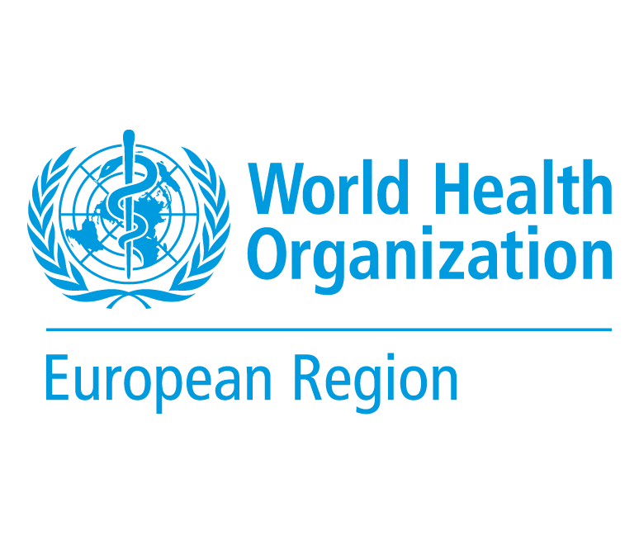
The report, launched at the Second WHO Symposium on the Future of Health Systems in a Digital Era in the European Region, covers all 53 Member States of the Region. While in many countries the COVID-19 pandemic accelerated the creation and use of digital health tools and policies in response to lockdowns and social distancing, including telemedicine and user-friendly health apps, the report underscores that there is still much work to be done. A key risk is the digital health divide being created because of the uneven deployment and uptake of digital solutions. This means that millions of people region-wide are still unable to benefit from digital health technology.

The report shows that the vast majority of countries in the Region (44) have a national digital health strategy. Importantly, all 53 Member States have legislation safeguarding the privacy of personal data. But the report also highlights significant gaps and areas for improvement:

- Only 19 countries have developed guidance on how to evaluate digital health interventions, which is vital to ensure they are safe and effective.
- Just over half the countries in the Region have developed policies for digital health literacy and implemented a digital inclusion plan.
- Thirty countries have introduced legislation to support telehealth during the COVID-19 pandemic.
- Many countries still lack a dedicated entity responsible for oversight of mobile health (mHealth) apps, in terms of quality, safety and reliability, with just 15% reporting evaluations of government-sponsored mHealth programmes.
- Slightly more than half of the countries have developed a data strategy regulating the use of Big Data and advanced analytics in the health sector.

Dr Hans Henri P. Kluge, WHO Regional Director for Europe said, ‘…In many countries, digital health programmes have so far developed on an ad-hoc basis and this needs to change. To realize the full potential of digital health, it needs to be seen as a strategic long-term investment rather than an add-on or a luxury for the few. This calls for political will at the highest levels of government and health, to ensure optimal investments in digital health infrastructure of the future now, rather than later…’

You may find more information about this article here.

Determinants of the onset and prognosis of the post-COVID-19 condition: a 2-year prospective observational cohort study

On September 4th, a scientific study was published in The Lancet Regional Health – Europe. Lourdes Mateu et al. conducted a prospective cohort analysis spanning two years to systematically characterize the evolution and clinical presentation of post-coronavirus disease 2019 (COVID-19) condition (PCC). The study aimed to identify factors associated with the onset and recovery of PCC and explore the potential presence of different subsyndromes.

Background

At least 5–10% of subjects surviving COVID-19 develop the post-COVID-19 condition (PCC) or “Long COVID”. The clinical presentation of PCC is heterogeneous, its pathogenesis is being deciphered, and objective, validated biomarkers are lacking. It is unknown if PCC is a single entity or a heterogeneous syndrome with overlapping pathophysiological basis. The large US RECOVER study identified four clusters of subjects with PCC according to their presenting symptoms. However, the long-term clinical implications of PCC remain unknown.

Methods

The researchers conducted a 2-year prospective cohort study of subjects surviving COVID-19, including individuals fulfilling the WHO PCC definition and subjects with full clinical recovery. After that they systematically collected post-COVID-19 symptoms using prespecified questionnaires and performed additional diagnostic imaging tests when needed. Factors associated with PCC were identified and modelled using logistic regression. Unsupervised clustering analysis was used to group subjects with PCC according to their presenting symptoms. Factors associated with PCC recovery were modelled using a direct acyclic graph approach.

Findings

The study included 548 individuals, 341 with PCC, followed for a median of 23 months, and 207 subjects fully recovered. In the model with the best fit, subjects who were male and had tertiary studies were less likely to develop PCC, whereas a history of headache, or presence of tachycardia, fatigue, neurocognitive and neurosensitive complaints and dyspnea at COVID-19 diagnosis predicted the development of PCC. The cluster analysis revealed the presence of three symptom clusters with an additive number of symptoms. Only 26 subjects (7.6%) recovered from PCC during follow-up; almost all of them (24) belonged to the less symptomatic cluster A, dominated mainly by fatigue. Recovery from PCC was more likely in subjects who were male, required ICU admission, or had cardiovascular comorbidities, hyporexia and/or smell/taste alterations during acute COVID-19. Subjects presenting with muscle pain, impaired attention, dyspnea, or tachycardia, conversely, were less likely to recover from PCC.

Interpretation

Preexisting medical and socioeconomic factors, as well as acute COVID-19 symptoms, are associated with the development of and recovery from the PCC. Recovery is extremely rare during the first 2 years, posing a major challenge to healthcare systems.

To read the full article, click here.

