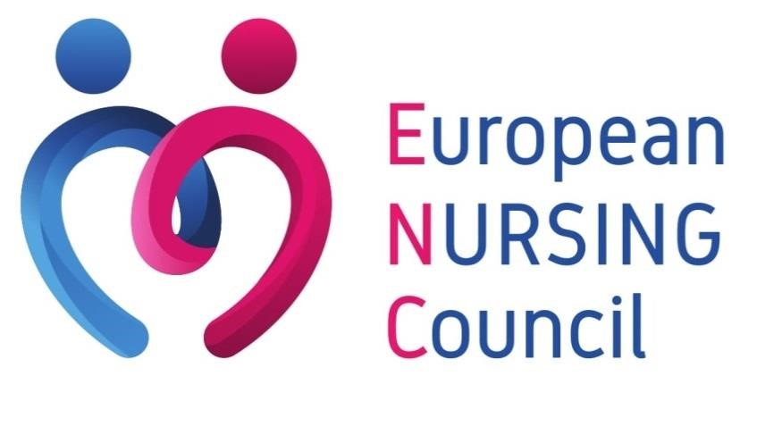

News from Brussels

Year 2024 – Issue n°1
#1

- European Commission and WHO/Europe sign €12 million agreement to strengthen health information systems and boost health data governance and interoperability in Europe
- Reports confirm the European Health Union is better prepared to combat health threats
- European Commission publishes first Union Critical Medicines list to tackle shortages
- European Parliament: New EU rules needed to address digital addiction
- Event: ENSA Executive Board Meeting

European Commission and WHO/Europe sign €12 million agreement to strengthen health information systems and boost health data governance and interoperability in Europe
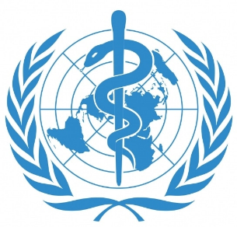
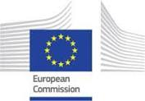
WHO/Europe and the European Commission have embarked on an ambitious new partnership to strengthen health information systems and boost health data governance and interoperability in the WHO European Region. The €12 million project, funded by the Commission, will support health-care services for the nearly 1 billion people living across the 53 countries in the Region.
Harnessing health data
This 4-year project aims to improve the use and reuse of health data by health-care providers, policy-makers and patients, and to enhance the quality and interoperability of health information systems.
For these purposes, WHO/Europe and the Commission will develop and deliver capacity-building activities and assistance aimed at addressing gaps, needs, and areas of expertise, within supported countries’ health information systems and health data governance and capabilities, with a view to potentially expanding successful practices at country or regional levels.
Ms. Sandra Gallina, Director-General for Health and Food Safety at the Commission, explained, “Having robust health information systems and accessible health data can improve the efficiency, safety and personalization of health care. This is why the Commission has developed the proposal for a European Health Data Space (EHDS), part of a strong European Health Union.”
Advancing European cooperation
The project will promote cooperation among participating countries, the Commission, WHO/Europe and external stakeholders. One key aspect will be the establishment of the Health Information Network, a network of countries engaged in collaborative decision-making, meaningful dialogue and knowledge exchange.
The initiative will be driven by the principles and ideas proposed in the European Health Data Space framework to facilitate the use and reuse of health data within the EU. The proposal for a regulation on the EHDS is currently under negotiation in the European Parliament and Council, and will make a major contribution to digital transformation in the health-care sector.
The project agreed will support the goals of the EU Global Health Strategy, as well as the European Programme of Work 2020-2025, the Regional Digital Health Action Plan for the WHO European Region 2023-2030, and the WHO Global Strategy on Digital Health 2020-2025.
Background
Systems that store health-care data, including medical records, are known as health information systems. For health information systems to be impactful and cost-effective, they need consistent and well-structured data. They also need to be able to connect and exchange information with each other across national and international boundaries. This is called interoperability.
The project is funded under the EU4HEALTH programme in alignment with its objective to “Protect people in the Union and its neighbourhood from serious cross-border threats to health”, under the theme of health data governance and interoperability.
For further information about the article, click here.
Reports confirm the European Health Union is better prepared to combat health threats
Two new reports published the 15th of December show how the EU has responded to the need and demand for more resilient, robust, and equitable health systems, which are better prepared for potential crises. Both documents also spotlight areas in which more work is needed.
Four years after COVID-19 cases were first detected, many of the solutions brought forward to respond more effectively to the pandemic have been enshrined into EU legislation. The aim has been to strengthen our collective preparedness against health crises, as part of a strong European Health Union. The 2023 State of Health Preparedness report focuses on the steps taken by the EU to improve its capacity to face serious cross-border health threats.
The State of Health in the EU: Synthesis report 2023 examines how health systems are performing across the Union in meeting the needs of European citizens. It includes dedicated Country Health Profiles, where particular attention is given to the mental health impact of COVID-19 and reforms carried out by Member States to address this growing challenge.
A better prepared European Health Union
The purpose of the yearly State of Health Preparedness Report is to map EU actions taken since the pandemic to address cross-border health threats. The Regulation on serious cross-border threats to health, in force for almost one year, is the backbone of the EU's health security architecture. It has created a solid basis for more effective preparedness and a coordinated response to cross-border health risks. It will allow Member States to quickly react to future crises.
Structures like the EU Health Security Committee have been upgraded, EU laboratory capacities are being enhanced and EU funding of nearly €100 million from the EU4Health programme is being channelled to Member States, to improve their national surveillance systems. Member States continue to coordinate closely within the Health Security Committee, which has issued an Opinion on preparing COVID-19 and other respiratory diseases for winter 2023-2024.
The report notes that vaccination continues to be key to preventing the spread of infectious diseases. During the COVID-19 pandemic, the EU Vaccines Strategy supported the development of vaccines and ensured their availability to all Member States as well as to third countries. In terms of the most pressing health threats, the report sheds light on the issue of antimicrobial resistance (AMR), which causes over 35,000 deaths a year in Europe, and needs urgent action. Threats from animal diseases and the rising health impacts of climate change are two other major challenges highlighted in the report.
A strong commitment to improving mental health in our Union
The State of Health in the EU report, accompanied by 29 Country Health Profiles, highlights three key findings that need to be addressed in the aftermath of the COVID-19 pandemic:
- Mental health of EU citizens deteriorated following the pandemic. Therefore, mental health reforms that cover de-stigmatisation, prevention, treatment and reintegration are needed across all Member States. At EU level, the Commission adopted a comprehensive approach to mental health in June 2023, consisting of 20 flagship initiatives and backed by €1.23 billion in funding.
- The State of Health report stresses the need to address growing health inequalities across the Union, as well as increasing unmet medical needs. The COVID-19 pandemic led to a widening of the gap in life expectancy at birth between 2019 and 2021 across Member States. However, life expectancy estimates from 2022 show a narrowing of the gap. In this respect, cancer is highlighted as a key priority area to address. The Commission has already taken a number of important steps in this regard, including a number of important initiatives under Europe's Beating Cancer Plan.
- The report also highlights the importance of continued investment in health, to prepare for potential future crises. One particularly important area is the continued need for comparable and valid health data, which is key for informed policy making and effective health innovations. The European Health Data Space, proposed by the Commission in May 2022, will help to unleash the full potential of health data and empower EU citizens through better digital access and control of their health information.
For further information about the report, click here.
European Commission publishes first Union Critical Medicines list to tackle shortages
The 12th of December, the European Commission published the first Union list of critical medicines, together with the European Medicines Agency (EMA) and the Member States' Heads of Medicines Agencies (HMA). The publication follows the commitment made in the Commission's Communication on addressing medicine shortages in the EU to accelerate the work on this list, originally announced in the EU's pharmaceutical reform proposal. It is an important part of the EU's efforts under the European Health Union to ensure patients have the medicines they need, by fostering the security of supply of critical medicines and preventing shortages from occurring. It is also part of the EU's efforts to improve its resilience and strategic autonomy in the face of geopolitical and unexpected challenges.
A medicine is listed as critical when it is essential to ensure the provision and the continuity of quality healthcare, and to guarantee a high level of public health protection in Europe. This first Union critical medicines list contains more than 200 active substances used in human medicines, which are considered essential in the EU.
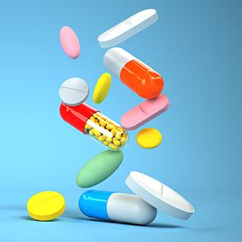
The inclusion on this list is not an indication that a medicine is likely to experience a shortage in the near future. Rather, it signifies the critical importance of averting shortages for these specific medicines, as its unavailability could cause significant harm to patients and pose substantial challenges to health systems.
The list was developed alongside with the EMA and all EU Member States. It follows a strict methodology to assess criticality, initially developed during the Commission's Structured dialogue on security of medicines supply launched under the Pharmaceutical Strategy, which was conducted in 2021 and drew lessons from the COVID-19 pandemic. Key stakeholder groups, including patients and healthcare professional organisations and industry associations, were consulted.
Ensuring the uninterrupted supply of critical medicines of the Union list is a top priority for the Commission. It will take all necessary steps to work hand in hand with the Member States and relevant stakeholders in order to prevent shortages, including implement additional measures if required.
Next steps
The Union list of critical medicines will be reviewed annually and will be used to support and expedite the Commission's analysis of vulnerabilities in the supply chains of the critical medicines that are included on the list, following a staged approach.
On this basis, the Commission and EMA, together with the Member States (through the Executive Steering Group on Shortages and Safety of Medicinal Products), may recommend measures to address those vulnerabilities. This would be done, where relevant, in consultation with the Critical Medicines Alliance to be set up in early 2024.
For further information about the article, or for the Union list of critical medicines, click here.

European Parliament: New EU rules needed to address digital addiction
The 12th of December, the European Parliament published an article detailing its call for the development of ethical digital products that do not rely on dark patterns and addictive designs.
In a report adopted the same day, with 545 votes in favour, 12 against and 61 abstentions, MEPs are warning warn of the addictive nature of online games, social media, streaming services, and online marketplaces, which exploit users’ vulnerabilities to capture their attention and monetise their data. MEPs want to increase consumer protection through safer alternatives, even if these are not as profitable for social media platforms.
New EU rules needed
Parliament urges the European Commission to address existing legal gaps and introduce new legislation against addictive design. If not addressed, MEPs say, Parliament should use its right of legislative initiative. Their report calls for an assessment and a ban on harmful addictive techniques not covered by the Directive on Unfair Commercial Practice, such as infinite scroll, default auto play, constant push and read receipt notifications.
Ethical by design
Highlighting the lack of transparency consumers and enforcers experience on online services, MEPs believe companies should be obliged to develop ethical and fair digital products and services “by design” without dark patterns, misleading, or addictive design.
To mitigate the addictive nature of platforms and empower consumers, the Commission is urged to present a digital “right not to be disturbed”. MEPs also want the Commission to create a list of good design practices like “think before you share”, turning off notifications by default, chronological feeds, greyscale mode, automatic locks, and total screen time summaries. They also propose awareness-raising campaigns to cultivate safer and healthier online habits.
Mental health effects
Acknowledging the positive effect social media can have on society, MEPs are concerned about the physical, psychological, and material harm addictive design can have, including loss of concentration and cognitive ability, burnout, stress, depression, limited physical activity. They are particularly worried about the prolonged impact on minors’ health, and want more research on the risks related to online services.
Following the vote, rapporteur Kim Van Sparrentak, MEP (Greens/EFA, NL) said: “No self-discipline can beat Big Tech’s tricks, fuelled by armies of designers and psychologists to keep you glued to your screen. If we do not act now, this will have an impact on the mental health and brain development of generations to come. Today, the European Parliament sends a strong signal: the EU has to be the first in the world to tackle the addictive design of online services”.
Next steps
The European Commission is currently evaluating the need to update certain consumer protection legislation to ensure a high level of protection in the digital environment, with results to be expected in 2024. Parliament’s report will feed into this ongoing fitness check.
Ms. Kim van Sparrentak, MEP (Greens/EFA, NL)
Background
Problematic smartphone or internet use has been linked to lower life satisfaction and mental health symptoms such as depression, low self-esteem, anxiety, lack of sleep, and obsessive-compulsive behaviour, with children and young people the most vulnerable. Young people aged from 16 to 24 spend an average of over seven hours a day on the internet, with one in four displaying problematic smartphone use resembling addiction.
For further information about the article, click here.
Event: ENSA Executive Board Meeting
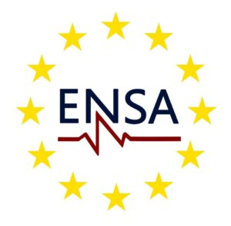
The 12th of January, ENSA (European Early Career Nurses and Nursing Students’ Association) is going to hold its Executive Board meeting in Vienna, during which it will highlight the key pillars that will guide its action, define its goals and aspirations, as well as its vision of the future of the nursing profession.
Online participation to the meeting will be possible via a link.
Participants’ active involvement will be crucial, as a Q&A session is going to take place at the end of the presentation, to address inquiries directly to the Board.
To register to the event, click here.

